JUNE 2016

SECTION I

(1) (a) Explain why the homogeneity of a physical equation is not a sufficient condition for the correctness of a physical equation?

(b) Faradays may be stated in the form E=-L dI/dt where, E is the induced Emf, L is the inductance of a coil and di/dt is the rate of change of current. Determine the base units of L if the equation is homogenous. (6 marks)

(2) A simple pendulum of length l, has a period , T on the surface of the earth. The simple pendulum is carried to a space craft to a height of 2R , above the earth’s surface where R is the radius of the earth.

Explain whether the period of the pendulum at this would increase or reduce. (6 marks)

3 (a) Distinguish between thermionic emission and the photo-electric effect

(b) An electromagnetic radiation of wavelength 6.3 x 10-14 m falls on a clean metal surface which has a work function of 2.25 x 10-14 J. Explain whether photoelectrons would be emitted or not. (6 marks)

4 (a) A transformer can not be used to run a 230 v , 100 w mains lamp directly from a 12 v car battery.

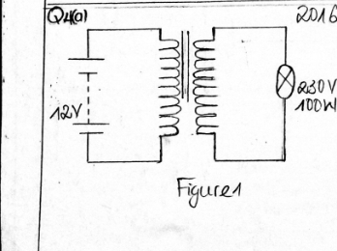

Suggests in terms of fields and energy while the system can not work.

(b) (I) Discuss how the system can be adapted to function

(ii) What type of transformer does figure 1 represent (5 marks)

5 Figure 2 shows how resistors and cells may be connected in an electric circuit.

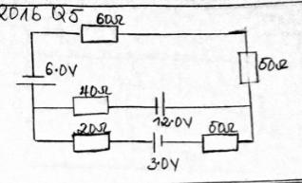

Calculate the :

(i) current flowing through the 40 Ω resistor

(ii) Voltage drop across the 80 Ω resistor (6 marks)

ANSWER a, b and c or d, e f and g

6 (a) (i) Distinguish between longitudinal and transverse waves (4 marks)

(ii) Describe an experiment to determine the speed of sound air. Your account should include a diagram , procedure observations, precautions , and conclusion. (8 marks)

(b) a source of sound whose frequency 51.6 Hz is placed in front of a flat vertical smooth wall, if a microphone is moved from the source directly towards the walls , a series of maximum and minimum values in its output are observed at equally spaced intervals.The speed of sound at room temperature is 330 m/s.

(i) Explain how this minimum positions are formed.

(ii) Calculate the separation of these minimum points

(iii) What can be done to increase the separation calculated in (ii) above (8 marks)

(d) Explain why the specific capacities are either measured at constant pressure or at constant volume while this is not required for solids and liquids. (4 marks)

(e) Describe an experiment to determine the specific heat capacity of liquid. Your account should include a diagram , procedure, observations, precautions and conclusion. (8 marks)

(f) In terms of molecular behavior explain,

(i) How liquids are similar to gases but different from solids

(ii) how solids are similar to liquids but different from gases. (4 marks)

(g) A highly lagged compound bar 25.0 cm long is made from a copper bar 15.0 cm joined to an aluminum bar of equal cross sectional area. The free end of the copper is maintained at 1000c while that of aluminum maintained at 00c. Calculated the temperature of each of the bars under steady state, given that the ratio of the thermal conductivities of copper to aluminum is 15:7. (4 marks)

SECTION III

DATA ANALYSIS

7 Table 1 shows the force, F , between two charged particles in a substance. The force is given by the equation 2/r24. In order to confirm the relationship the following data was recorded for various values of F and r, the distance between the charged particles. Q = 4.4 x 10-4C.

|  |  |  |  |  |  |  |  |  |  |
| --- | --- | --- | --- | --- | --- | --- | --- | --- | --- |
| F/N | 1.0 | 1.5 | 2.0 | 2.5 | 3.0 | 4.0 | 4.5 | 5.0 | 6.0 |
| r/nm | 355.1 | 297.5 | 258.2 | 230.3 | 210.8 | 182.6 | 172.0 | 163.3 | .149.0 |

Table 1

(a) Plot a suitable graph from which could be determined (10mark)

(b) (i) Find the slop S of the graph

(ii) what does the S represent?

(iii) Calculate a value of (8 marks)

(c) What will be the nature of the forces if the experiment was conducted of higher dielectric constant? (2 marks)

SECTION III

ENERGY RESOURCES AND ENVIRONMENTAL PHYSICS

8 (I) What do you understand by finite and renewable energy sources? (2 marks)

(ii) Given that the mean distance of the earth from the sun is 1.5 x 1011 m and the power of the sun is 4 x 1026 W, calculate a value for the solar constant. (4 marks)

State the assumption that you have made in your calculation.

(b) Describe the process by which electrical energy could be obtained from the following sources of energy.

- Geothermal energy

- Wind energy (5 marks)

(c) (i) Discuss the consequences on humanity of the destruction of the ionosphere layer.

(ii) Explain ways by which the ionosphere can be protected from destruction. (4 marks)

COMMUNICATION

9 (a) (i) Draw a basic block diagram of a mobile telephone handset. (3 marks)

(ii) Compare the use of the optical and the copper cable in the transmission of information in terms of

Security

Noise

Signal attenuation (6 marks)

(b) (I) What is the meaning of the following abbreviation

- SIM

- SMS (4 marks)

(c) Explain how a radio receiver works. (2 marks)

ELECTRONICS

10 (a) Explain why a piece of pure silicon may not conduct electricity at 00c but would conduct at 800c. (4 marks)

(b) A capacitor , an ammeter, and an Ac power source are connected in series and the reading on the ammeter noted. The capacitor and the ammeter and disconnected and connected to a Dc power source.The reading is also noted. Will the ammeter readings in the two cases be similar or different? Explain (4 marks)

Figure 3 is an amplification circuit using an NPN transistor in the common emitter mode. The base is current 25A when the output V0 is 6.0 v for a current gain of 60.

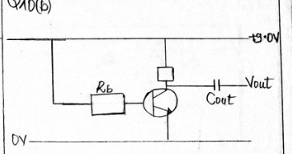

Calculate:

(i) The base resistance Rb (2 marks)

(ii) The value of Rl (3 marks)

(iii) Explain the use of the capacitor Cout (3 marks)

MEDICAL PHYSICS

11 (a) (I ) Draw a simple structure of the ear and describe how the ear functions. (4 marks)

(b) (i) Name two light sensitive receptors in the human eye.

(ii) By the reference to refraction at the cornea and the lens, draw a diagram showing how the rays from a distant object form a blurred image in the eye.

(iii) A patient suffering from long sight has a near point which is 1.5 m from his eyes, determine the type of lens that this patient should use to correct this defect. (8 marks)

(c) Explain the principle of operation for obtaining the ECG waveform. How is it useful in diagnosing heart problems?

(8 marks)